Test Case: tc005_SPX_Dev5_Crear_Requisicion_Spot_Con_FAD_Tipo_Cobro_Project
Step 1 - Enter username and password and click to button Enter: Credentials Entered
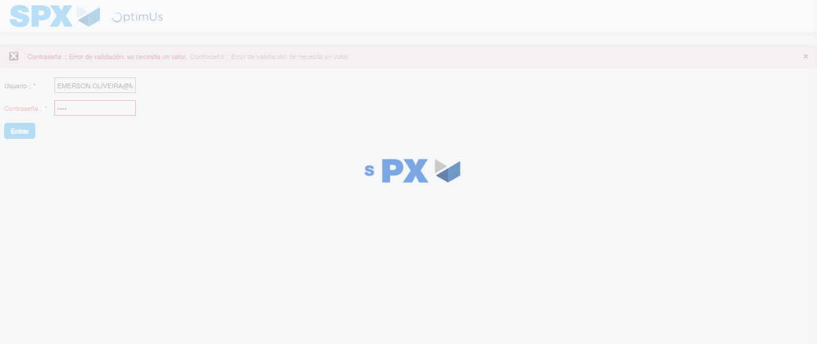Image file-name: QC_Testing-tc005_SPX_Dev5_Crear_Requisicion_Spot_Con_FAD_Tipo_Cobro_Project-1785975226191

Step 2 - Select to UEN and Access to Spot Buy Requisitions : UEN Correctly selected and Correct access
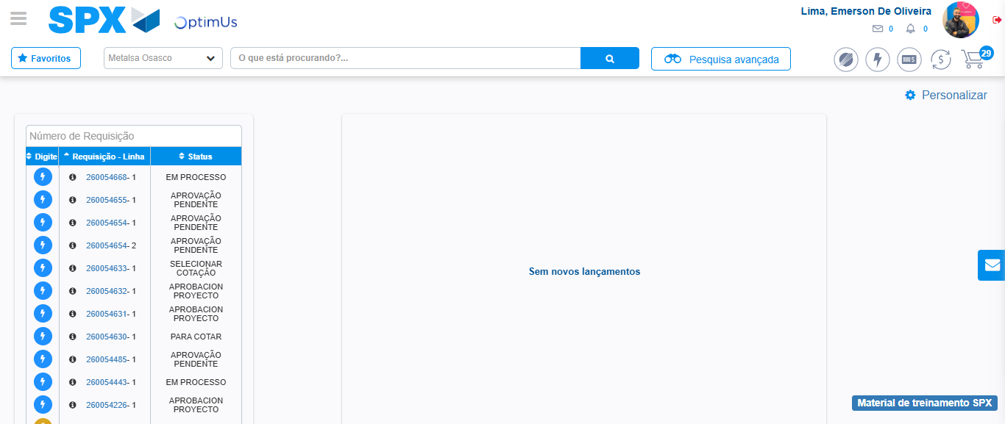Image file-name: QC_Testing-tc005_SPX_Dev5_Crear_Requisicion_Spot_Con_FAD_Tipo_Cobro_Project-1785975250978

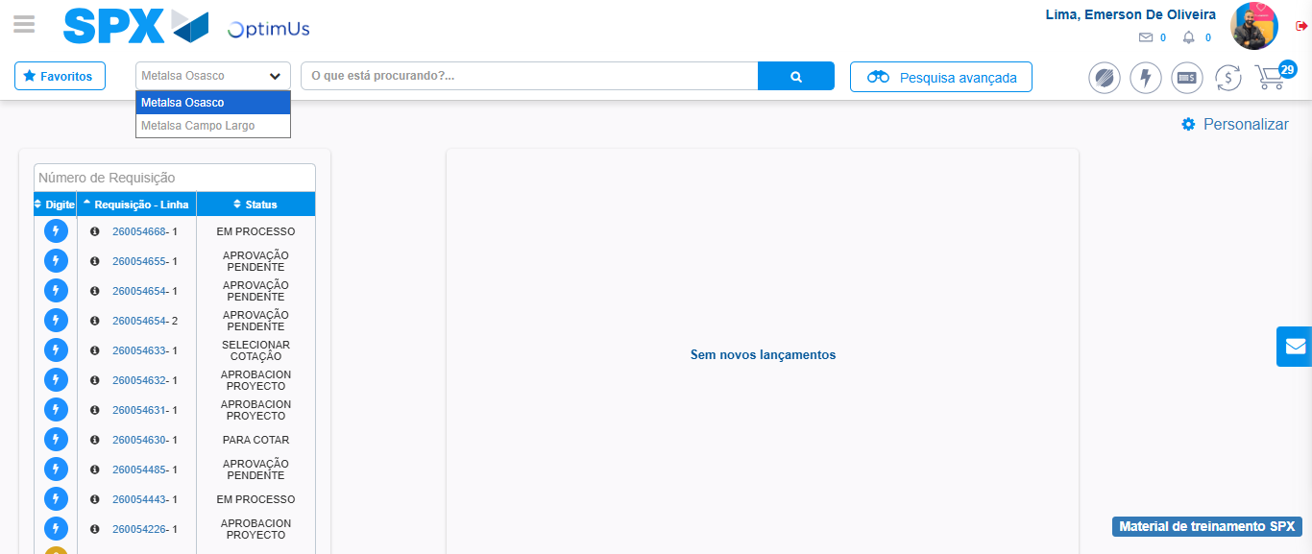Image file-name: QC_Testing-tc005_SPX_Dev5_Crear_Requisicion_Spot_Con_FAD_Tipo_Cobro_Project-1785975253403

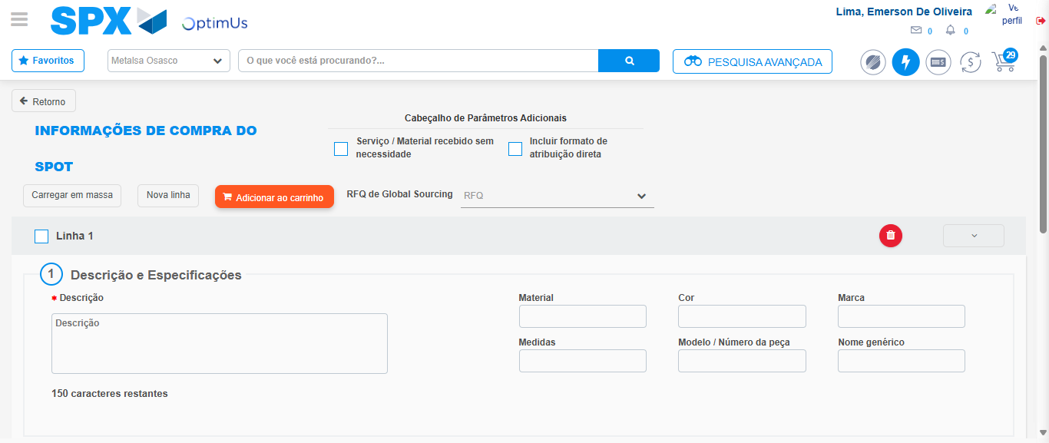Image file-name: QC_Testing-tc005_SPX_Dev5_Crear_Requisicion_Spot_Con_FAD_Tipo_Cobro_Project-1785975258023

Step 3 - Add FAD to Requisition: FAD Successfully Added
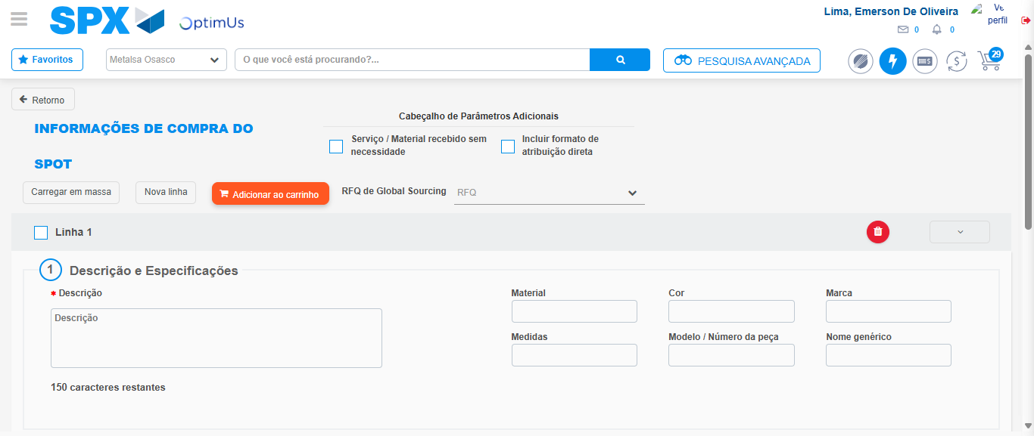Image file-name: QC_Testing-tc005_SPX_Dev5_Crear_Requisicion_Spot_Con_FAD_Tipo_Cobro_Project-1785975258294

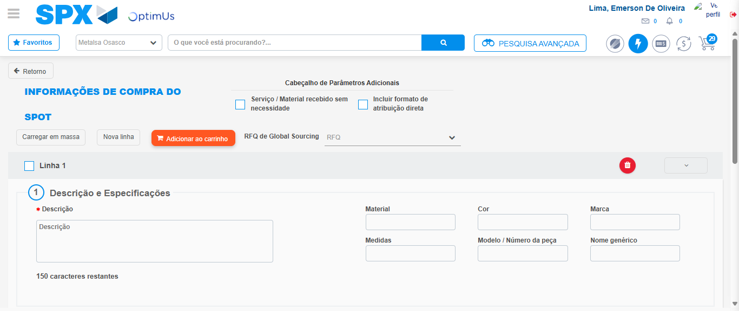Image file-name: QC_Testing-tc005_SPX_Dev5_Crear_Requisicion_Spot_Con_FAD_Tipo_Cobro_Project-1785975258481

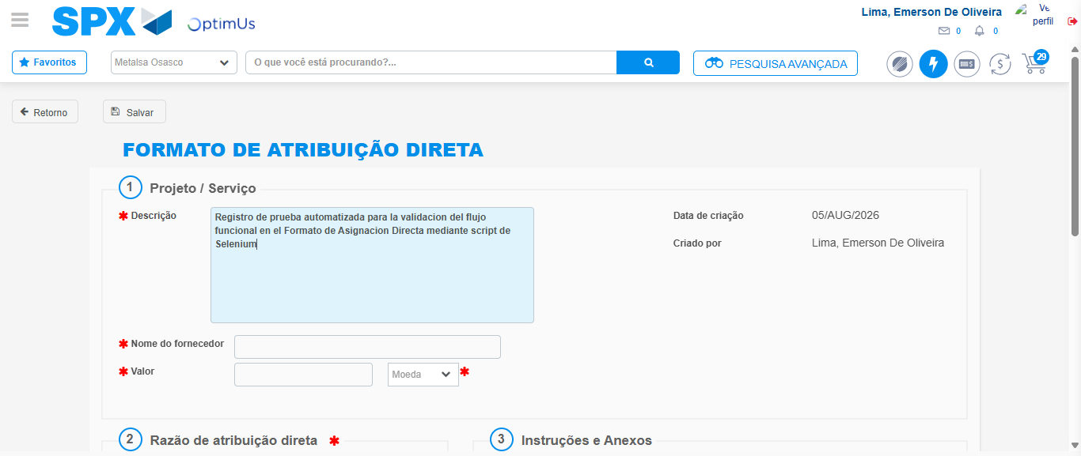Image file-name: QC_Testing-tc005_SPX_Dev5_Crear_Requisicion_Spot_Con_FAD_Tipo_Cobro_Project-1785975261241

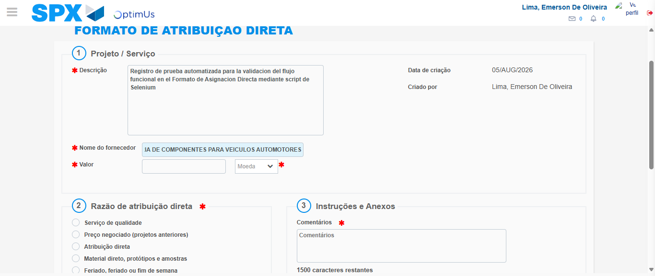Image file-name: QC_Testing-tc005_SPX_Dev5_Crear_Requisicion_Spot_Con_FAD_Tipo_Cobro_Project-1785975270554

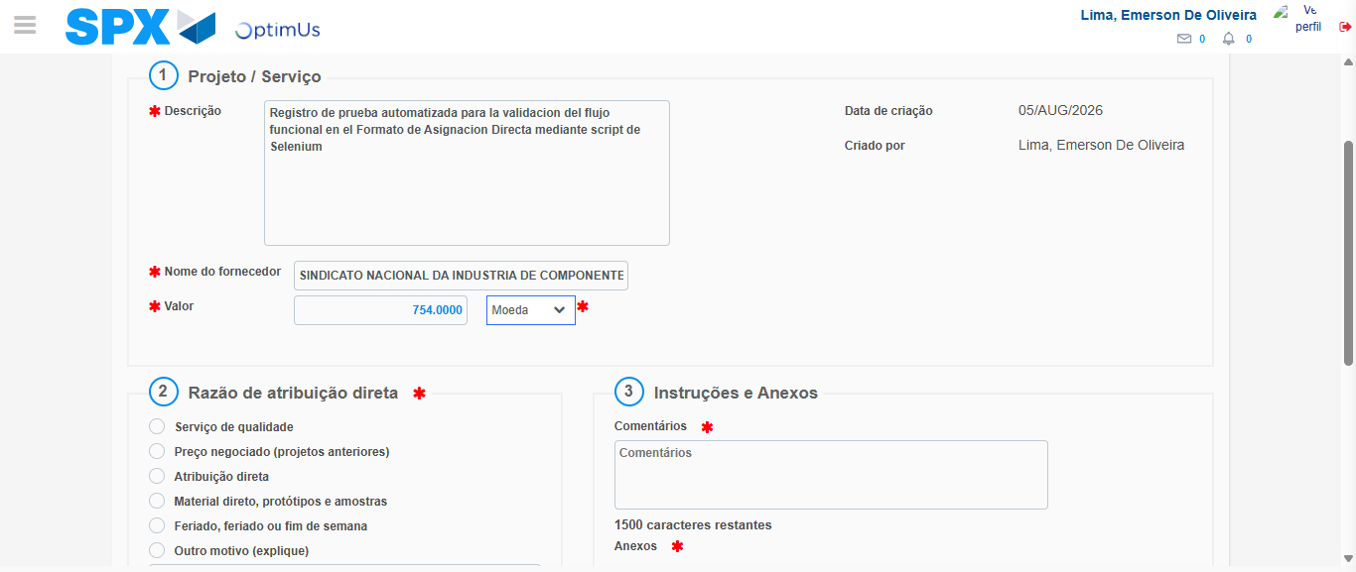Image file-name: QC_Testing-tc005_SPX_Dev5_Crear_Requisicion_Spot_Con_FAD_Tipo_Cobro_Project-1785975270978

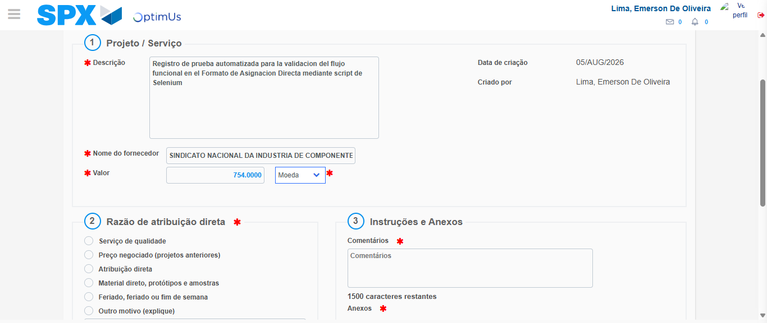Image file-name: QC_Testing-tc005_SPX_Dev5_Crear_Requisicion_Spot_Con_FAD_Tipo_Cobro_Project-1785975271177

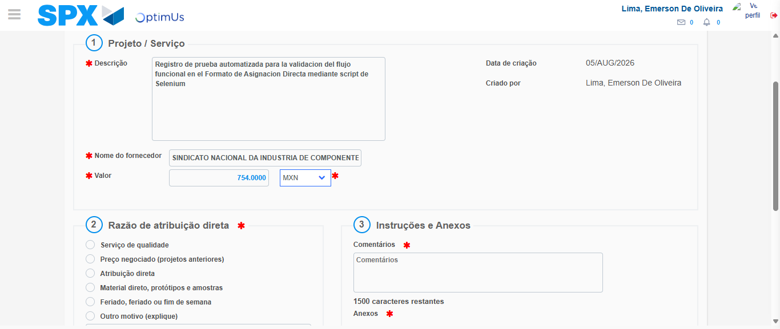Image file-name: QC_Testing-tc005_SPX_Dev5_Crear_Requisicion_Spot_Con_FAD_Tipo_Cobro_Project-1785975271545

Image file-name: QC_Testing-tc005_SPX_Dev5_Crear_Requisicion_Spot_Con_FAD_Tipo_Cobro_Project-1785975271756

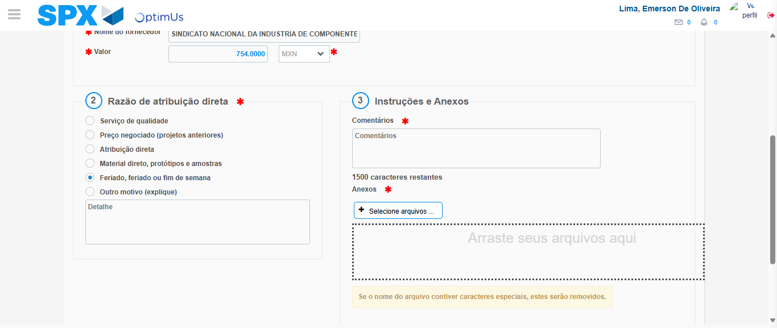Image file-name: QC_Testing-tc005_SPX_Dev5_Crear_Requisicion_Spot_Con_FAD_Tipo_Cobro_Project-1785975272594

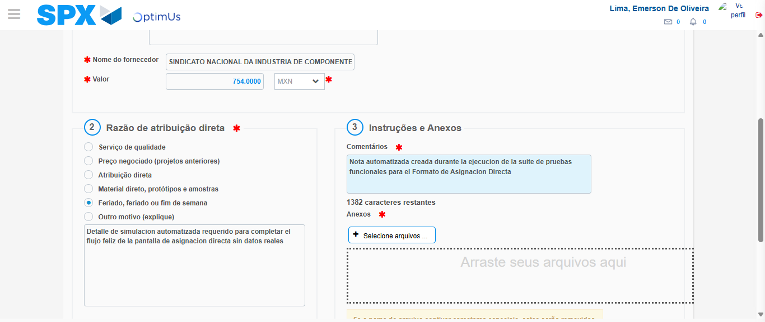Image file-name: QC_Testing-tc005_SPX_Dev5_Crear_Requisicion_Spot_Con_FAD_Tipo_Cobro_Project-1785975283620

Image file-name: QC_Testing-tc005_SPX_Dev5_Crear_Requisicion_Spot_Con_FAD_Tipo_Cobro_Project-1785975284317

Step 4 - Data Capture Spot Buy Requisition: Data captured correctly
Image file-name: QC_Testing-tc005_SPX_Dev5_Crear_Requisicion_Spot_Con_FAD_Tipo_Cobro_Project-1785975258294

Image file-name: QC_Testing-tc005_SPX_Dev5_Crear_Requisicion_Spot_Con_FAD_Tipo_Cobro_Project-1785975258481

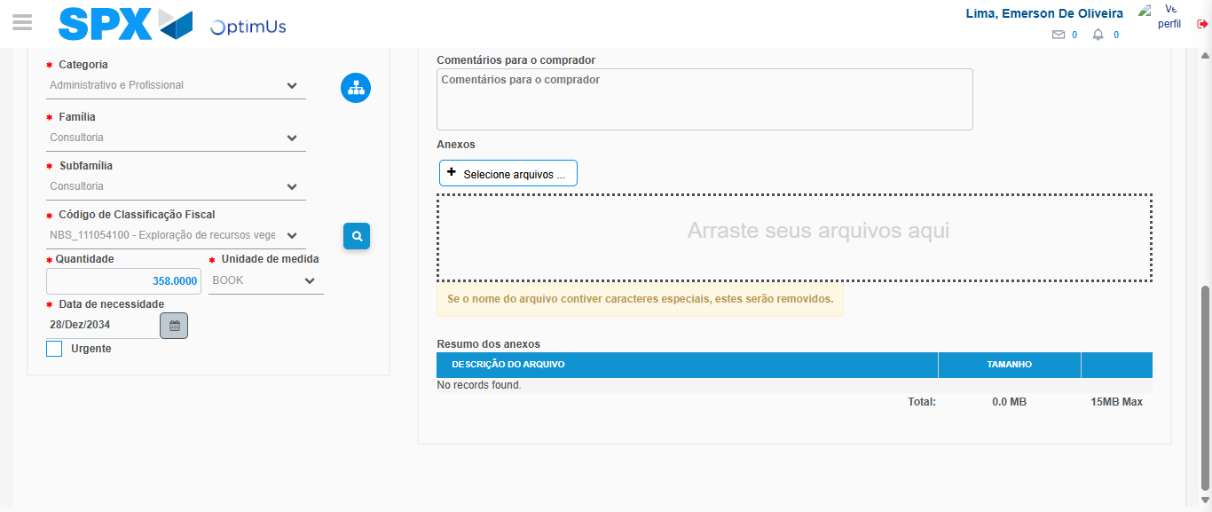Image file-name: QC_Testing-tc005_SPX_Dev5_Crear_Requisicion_Spot_Con_FAD_Tipo_Cobro_Project-1785975300926

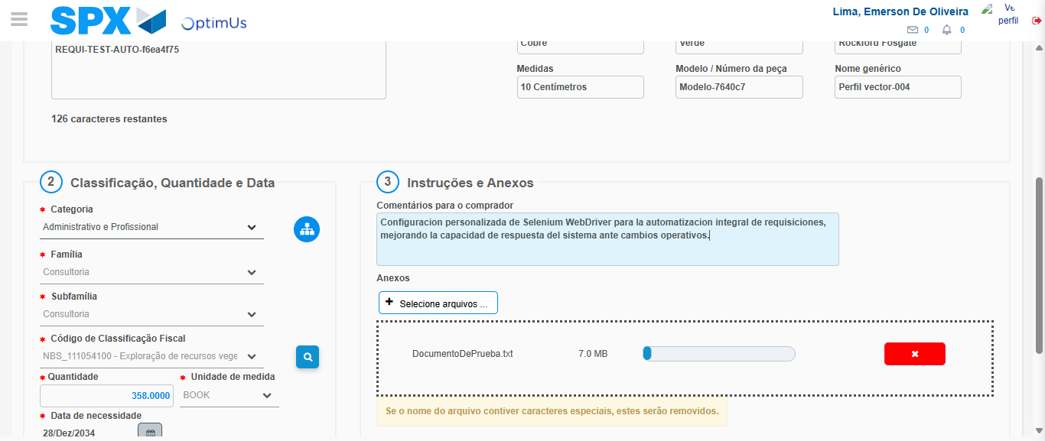Image file-name: QC_Testing-tc005_SPX_Dev5_Crear_Requisicion_Spot_Con_FAD_Tipo_Cobro_Project-1785975301665

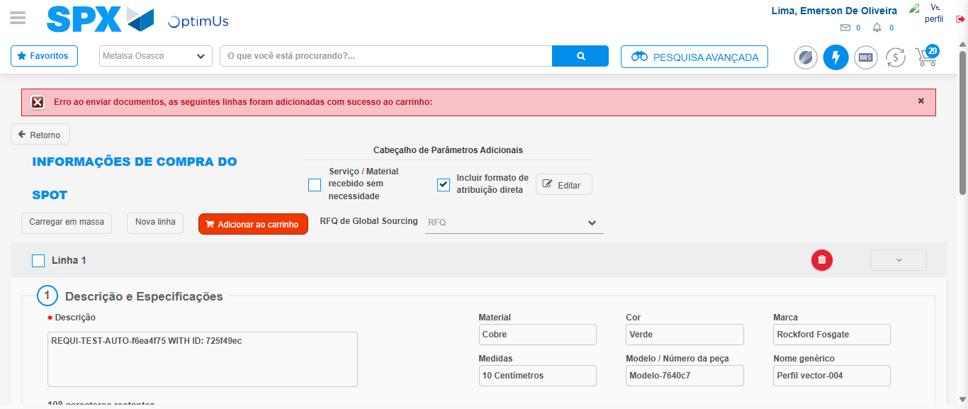Image file-name: QC_Testing-tc005_SPX_Dev5_Crear_Requisicion_Spot_Con_FAD_Tipo_Cobro_Project-1785975311294

Step 8 - Return to Main Page SPX : Return to Main Page SPX
Image file-name: QC_Testing-tc005_SPX_Dev5_Crear_Requisicion_Spot_Con_FAD_Tipo_Cobro_Project-1785975250978

Image file-name: QC_Testing-tc005_SPX_Dev5_Crear_Requisicion_Spot_Con_FAD_Tipo_Cobro_Project-1785975253403

Image file-name: QC_Testing-tc005_SPX_Dev5_Crear_Requisicion_Spot_Con_FAD_Tipo_Cobro_Project-1785975258023

Image file-name: QC_Testing-tc005_SPX_Dev5_Crear_Requisicion_Spot_Con_FAD_Tipo_Cobro_Project-1785975313517

Image file-name: QC_Testing-tc005_SPX_Dev5_Crear_Requisicion_Spot_Con_FAD_Tipo_Cobro_Project-1785975313708

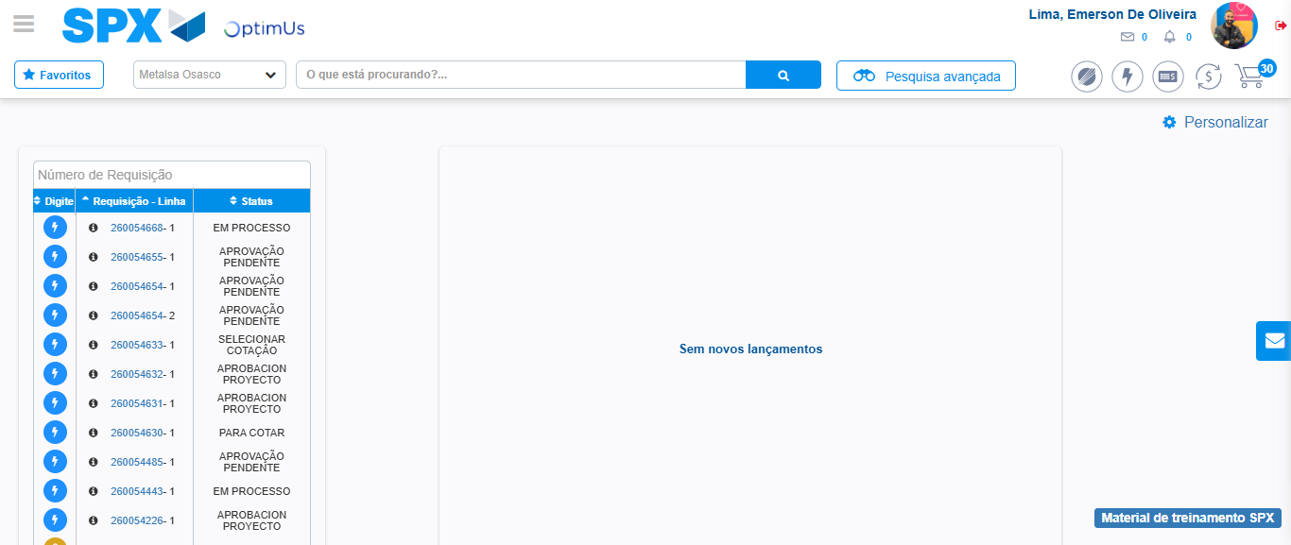Image file-name: QC_Testing-tc005_SPX_Dev5_Crear_Requisicion_Spot_Con_FAD_Tipo_Cobro_Project-1785975334619

Step 9 - Log Out : Log Out SPX
Image file-name: QC_Testing-tc005_SPX_Dev5_Crear_Requisicion_Spot_Con_FAD_Tipo_Cobro_Project-1785975334833

